**Jenkins Case Study**

1. Setup Jenkins Master and Slave on AWS. Access Jenkins Master by public-ip:8080 url.

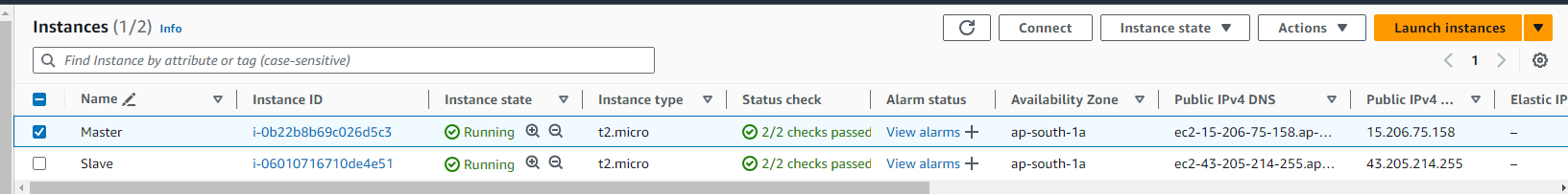

1. Add the Slave node in Jenkins Master.

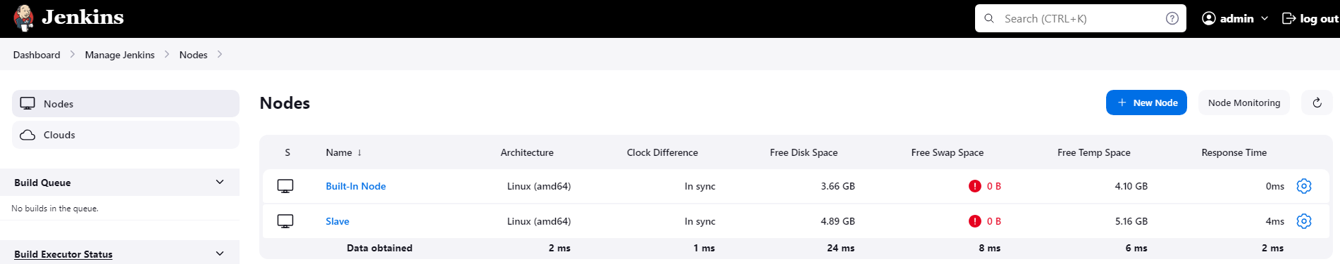

1. Build a Pipeline and pass on the below pipeline script.

pipeline {

agent any

stages {

stage('Checkout') {

steps {

script {

// Clone the repository

git 'https://github.com/hshar/website.git'

}

}

}

stage('Build and Publish') {

when {

anyOf {

branch 'master'

branch 'develop'

}

}

steps {

script {

// Build and publish based on branch

if (env.BRANCH_NAME == 'master') {

// Build and publish on port 82 for the master branch

sh 'docker run --rm -v $WORKSPACE:/var/www/html -p 82:80 my-apache-image'

} else if (env.BRANCH_NAME == 'develop') {

// Build only for the develop branch

sh 'docker run --rm -v $WORKSPACE:/var/www/html my-apache-image'

}

}

}

}

}

}

1. The above code ensures the requirement, to build and publish if code pushed in master and expose at port 82. Build only while code pushed in develop branch. I was not able to authenticate in git to push code as it’s deprecated. So the build was successful everytime since no pushes were made.

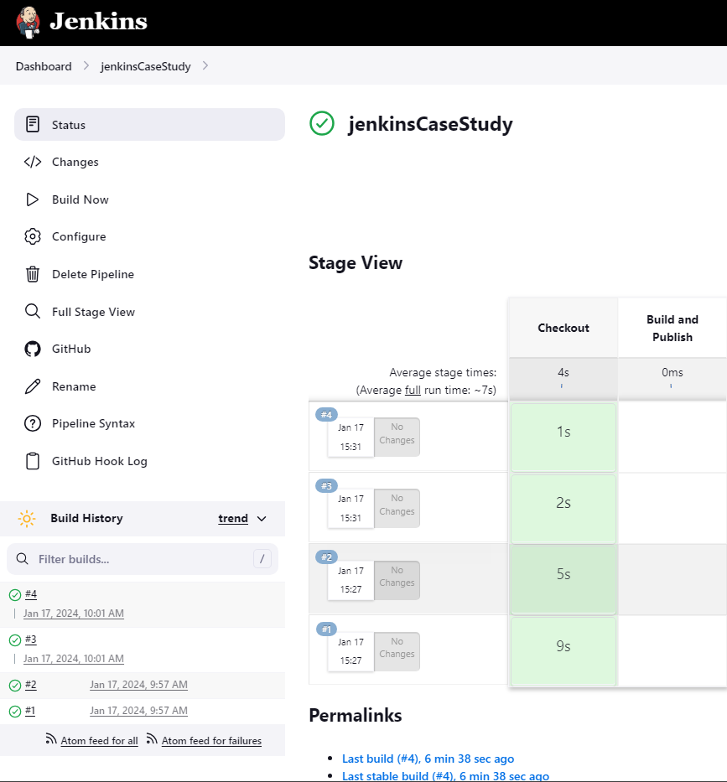

1. Additionally you need to build a dockerfile.

FROM ubuntu:latest

RUN apt-get update \

&& apt-get install -y apache2 \

&& apt-get clean \

&& rm -rf /var/lib/apt/lists/*

EXPOSE 80

CMD ["apachectl", "-D", "FOREGROUND"]

docker build -t my-apache-image .